Homework #10

1. **
2. **
3. *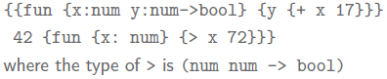*

is simplified term for $y:(num→bool)$, and $x..$ is simplified term for $x:num$ because of the lack of space…